Major Assignment

1. Program 1  
   
2. Program 2  
   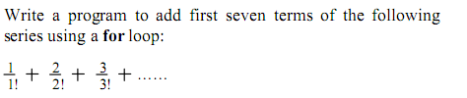
3. Program 3  
   
4. Program 4  
   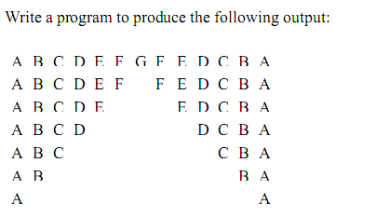
5. Program 5  
   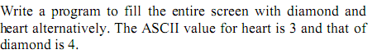
6. Program 6  
   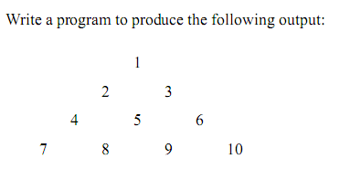
7. Program 7  
   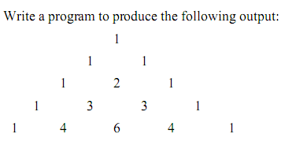
8. Program 8  
   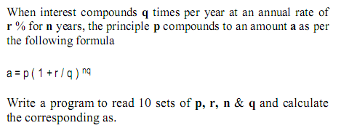
9. Program 9  
   
10. Program 10  
    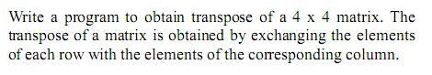
11. Program 11  
    
12. Program 12  
    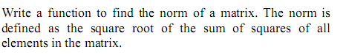
13. Program 13  
    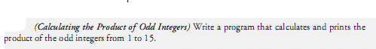
14. Program 14  
    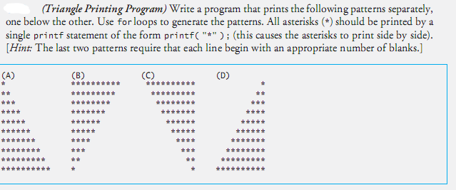
15. Program 15  
    